COMPONETS 3 ASSIGNMNET
3.Using the concept of Iparsys create your header and footer component according to ttn site .
I have created a base page whose resource super type is
ttn/components/structure/page

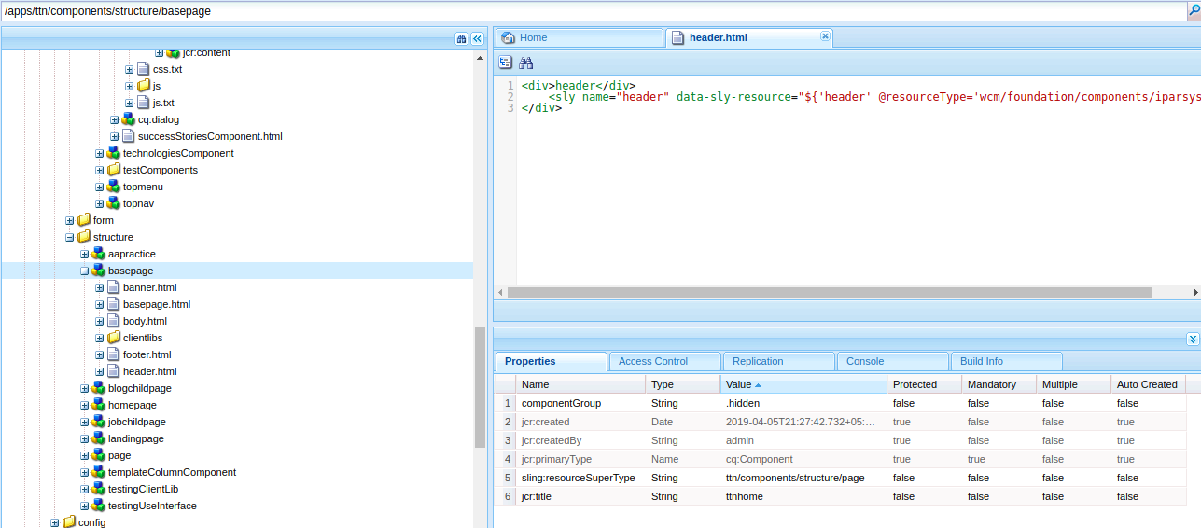
Where i have included header.html in which there is an iparsys. Where the header compoent will be dragged and dropped and will thus be inhertied on all child pages of base page.
Similarly with footer.html

